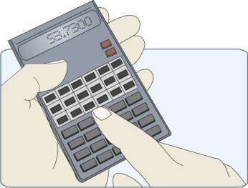
Ratio Analysis
Ratios compare two pieces of information so that it is possible to make informed judgement about a business’s performance. Ratio Analysis allows managers, directors, shareholders and other interested parties to place key figures such as profits and turnover into context. Ratio analysis does not guarantee good decision making but gives decision makers more information and so makes good quality decisions more likely.
Types of ratio

- Liquidity ratios measure the businesses ability to meet day-to-day expenditure. Does it have enough short term assets to cover short term liabilities?
Two common measures of Liquidity are : Current Ratio & Acid Test Ratio
- Profitability Ratios compare the profits earned by a business in relation to the level of sales achieved or the capital used in achieving that profit.
The 2 main types are: Operating Profit Margin (OPM) and Return on Capital Employed (ROCE).

- Financial Efficiency Ratios measure the effectiveness with which management control the internal operations of the business and how well they are managing the resources.
There are 4 types of Financial Efficiency ratios:
Asset Turnover Ratio Inventory Turnover Payables days Receivables days
These ratios consider the following aspects of management of a business:
- The extent to which assets are used to generate profits

- How well stock is managed
- How well the business makes use of credit facilities from suppliers
- The efficiency of creditor control – how long before customers settle
their accounts.
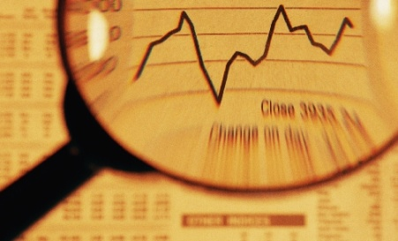
- Gearing examines the relationship between internal and external sources of finance. It is concerned with the long term financial position of the business. How much of the business is finance by long term debts.
This is simply called the Gearing Ratio.
- Shareholder ratios are of particular interest to the owners of a company or anyone considering buying shares in a particular company. These ratios allow comparison with alternative investments.
The 2 ratios are: Dividends per share and Dividend Yield.

